Learning Notes for .NET (Microsoft Stack)
Table of Contents
1 Introduction 1
2 Manage User Secrets 1
3 Class library 1
4 Debug Blazor WebAssembly 1
5 Two approaches to split a Razor component 4

Introduction
This is a summary of learning notes

Manage User Secrets
The connection string of the project in the developer own local development environment can be stored in User Secret file secret.json instead of appsettings.json.

The connection string in secret.json is used during development in developer’s local environment.

Class library
The class library can be created in a solution to be shared with other projects in the solution.

For sharing the class library with a project, a dependency of the project shell be added to be the class library as a reference of the project. In other word, the class library is added into the project as a reference of the project’s dependency.

Debug Blazor WebAssembly

information for debugging blazor
https://docs.microsoft.com/en-us/aspnet/core/blazor/debug?view=aspnetcore-5.0&tabs=visual-studio

press F5 to run the program in Visual Studio
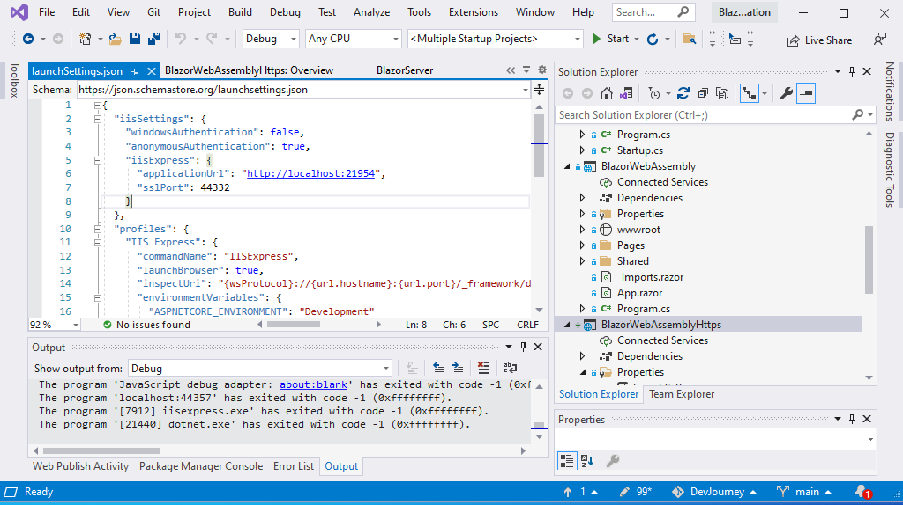

Press F5
To run the program

press Shift + Alt + d in the browser, a new tab will pop up
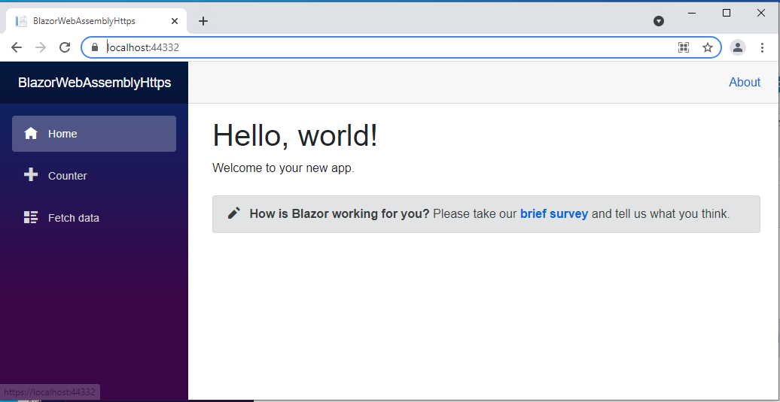

press Shift + Alt + d

Follow the instructions in the new tab below
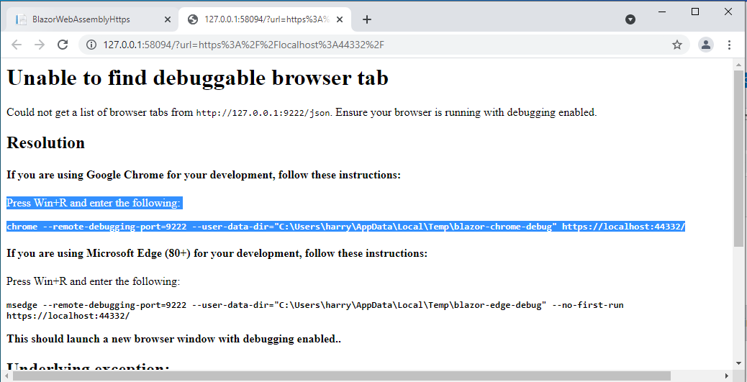

Follow the instructions in the new tab below

press Win + r
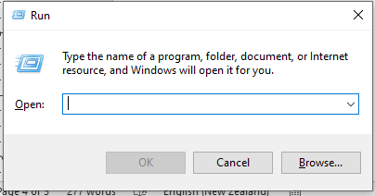

Run the command in the run window:
chrome --remote-debugging-port=9222 --user-data-dir="C:\Users\harry\AppData\Local\Temp\blazor-chrome-debug" https://localhost:44332/counter
(a new window of the app will pop up)
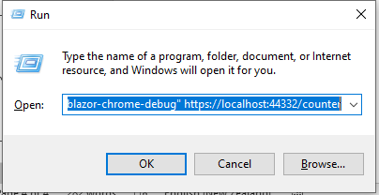

Press Shift + Alt + d at the new popped up browser window
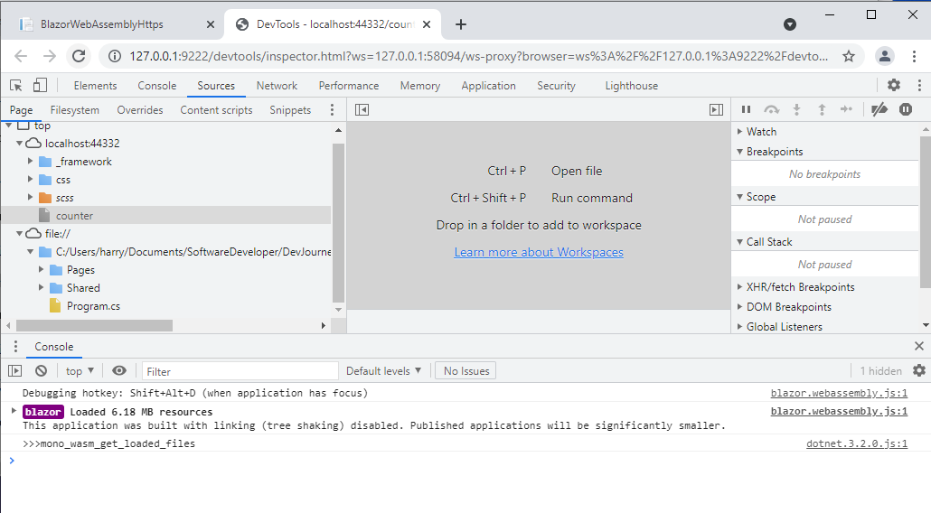
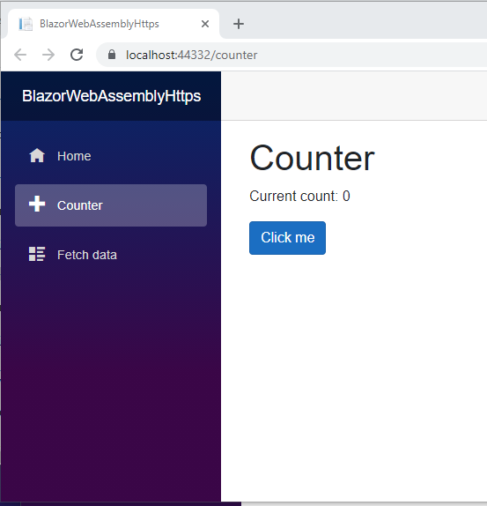
Press Shift + Alt + d

Debug from the codes

Two approaches to split a Razor component
Two ways of splitting a Razor component HTML and C# code into their own separate files are:
- Partial class approach
- Base class approach
Further information can be found at https://www.pragimtech.com/blog/blazor/Split-razor-component/

Array vs. List of C#

Array needs to know its size upfront
List is allowed to be expanded automatically and does not need to specify the size.

Blazor / Razor component lifecycle

Reference: https://docs.microsoft.com/en-us/aspnet/core/blazor/components/lifecycle?view=aspnetcore-5.0

